Gravity - 05
CLASS 09 - SCIENCE

 | Section A
1 | Priya buys a bag of sugar of weight W at a place on the equator. She takes it to Antarctica. The weight of a sugar bag at Antarctica  a) Remains same as the weight at a place on equator  b) Cannot be said  c) Decreases  d) Increases | [1]
2 | The upward force experienced by abody when submerged in a fluid is called  a) Buoyant force  b) Muscular force  c) Liquid force  d) Frictional force | [1]
3 | The amount of heat energy lost by hot body in a given time depend on:  a) all of these  b) the area of its surface  c) the temperature of its surface  d) the nature of the surface | [1]
4 | An object floats in water such that$\frac{1}{4}th$ its volume is above the surface of water. When the same object is made to float in a sample of impure alcohol, that volume that remains outside the liquid is $\frac{1}{10}$ total volume. The relative density of the sample of alcohol will be  a) 8.3  b) 0.083  c) 83  d) 0.83 | [1]
5 | Suppose, the acceleration due to gravity at the Earth’s surface is 10 m s$​^{−2}$ and at the surface of Mars is 4 m s $​^{−2}$ . A 60 kg passenger goes from the Earth to the Mars in a spaceship moving with a constant velocity. Neglect all other objects in the sky. Which part of figure best represents the weight (net gravitational force) of the passenger as a function of time? 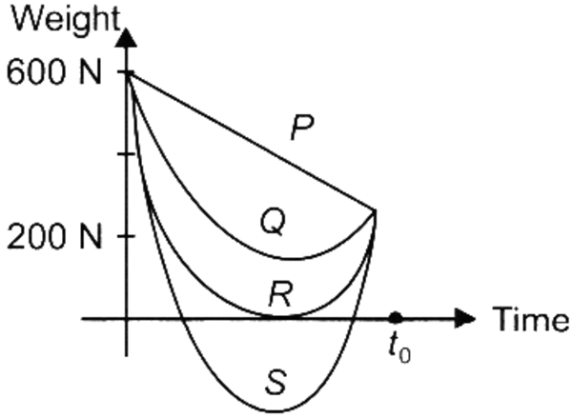  a) S  b) R  c) P  d) Q | [1]
6 | If the weight of an object in air and a dense liquid are W$​_{a}$ and W $​_{l}$ respectively, then upthrust  a) U = W$​_{l}$ + W $​_{a}$  b) U = 2W$​_{l}$  c) U = W$​_{a}$ - W $​_{l}$  d) U = W$​_{l}$ - W $​_{a}$ | [1]
7 | When a spaceship is two earth radii distant from the centre of the earth, its gravitational acceleration is  a) 4.9 ms$​^{−2}$  b) 19.6 ms$​^{−2}$  c) 2.45 ms$​^{−2}$  d) 9.8 ms$​^{−2}$ | [1]
8 | The value of quantity G in the law of gravitation  a) Is independent of mass and radius of the earth  b) Depends on both mass and radius of the earth  c) Depends on mass of the earth only  d) Depends on radius of the earth only | [1]
9 | Statement 1 : A pendulum can vibrate in an artificial satellite. Statement 2 : Inside the satellite, acceleration due to gravity is zero.  a) Statement 1 is true but statement 2 is false.  b) Statement 1 is false but statement 2 is true.  c) Both statements 1 and 2 are true and statement 2 is the correct explanation of statement 1.  d) Both statements 1 and 2 are true but statement 2 is not the correct explanation of statement 1. | [1]
10 | In a spring balance the space between 0 and 25 g marks is divided into 10 equal parts. The least count of spring balance is:  a) 15 g wt  b) 2.5 g wt  c) 25 g wt  d) 0.25 g wt | [1]
11 | A ball is thrown up and attains a maximum height of 100 m. It is thrown upwards with a speed of  a) 9.8 ms$​^{−1}$  b) 19.69 ms$​^{−1}$  c) 98 ms$​^{−1}$  d) 44.2 ms$​^{−1}$ | [1]
12 | The atmosphere is held to the earth by  a) Wind  b) Clouds  c) Earth’s magnetic field  d) Gravity | [1]
13 | If the volume of a body is V and half of it is immersed in the liquid, the upthrust will be proportional to:  a) Difference in density of the body and half the density of the liquid.  b) Half the volume  c) Volume  d) Double the volume | [1]
14 | A 60 kg man weight W kg on the moon. W is  a) 10 kg  b) 60 kg  c) 5 kg  d) 70 kg | [1]
15 | Acceleration due to gravity on the surface of the moon is$\frac{1}{6}$ th of its value on the surface of the earth as they have different  a) radius  b) All of these  c) density  d) mass | [1]
16 | A ball is thrown vertically upward, acceleration due to gravity is  a) In the direction same as the direction motion.  b) In the direction opposite to the direction of motion.  c) Increases as it comes down.  d) Becomes zero at the highest point. | [1]
17 | A stone dropped from a certain height takes 4 second to reach the ground. The height is  a) 19.6 m  b) 39.2 m  c) 78.4 m  d) 156.8 m | [1]
18 | A force acting perpendicular on an object is called as ________.  a) thrust  b) gravitational force  c) force only  d) work done | [1]
19 | If a planet existed whose mass was twice that of Earth and whose radius 3 times greater, how much will a 1 kg mass weigh on the planet?  a) 1.1 N  b) 25 N  c) 2.17 N  d) 5 N | [1]
20 | Variation of acceleration due to gravity g with distance r from the centre of earth with (r > R$​_{e}$ ) is best given as  a) g$∝$ r $​^{2}$  b) g$∝$ r  c) $g∝\frac{1}{r}$  d) $g∝\frac{1}{r^{2}}$ | [1]
21 | Acceleration due to gravity varies with  a) shape of the planet  b) All of these  c) height  d) depth | [1]
22 | Statement 1 : The weight of the body becomes zero at the centre of the earth. Statement 2 : As the distance from centre of earth decreases, acceleration due to gravity also decreases.  a) Both statement 1 and statement 2 are true but statement 2 is not the correct explanation of statement 1.  b) Both statement 1 and statement 2 are true and statement 2 is the correct explanation of statement 1.  c) Both statement 1 and statement 2 are false.  d) Statement 1 is true but statement 2 is false | [1]
23 | Earth goes round the Sun with  a) same velocity  b) varying K.E.  c) same momentum  d) varying velocity | [1]
24 | A student lowers a body in a liquid filled in a container. He finds that there is a maximum apparent loss in weight of the body when:  a) it is partially immersed and also touches the sides of the container.  b) it is partially immersed in the liquid.  c) it just touches the surface of the liquid.  d) it is completely immersed in the liquid. | [1]
25 | In a tank having ’h’ height of liquid, two points at a depth$\frac{3h}{4}$ from free surface have pressure P $​_{A}$ and P $​_{B}$ . When point A is closer to the wall than B. Then  a) P$​_{A}$ > P $​_{B}$  b) P$​_{A}$ < P $​_{B}$  c) P$​_{A}$ = P $​_{B}$  d) Depends on density | [1]
26 | A ball is released from the top of a tower of height h metres. It takes Tseconds to reach the ground. What is the position of ball above the ground in$\frac{T}{5}$ seconds?  a) $\frac{24}{25}h m$  b) $\frac{h}{25} m$  c) 25 hm  d) 24 hm | [1]
27 | The ratio of weight to mass of the body is ________.  a) zero  b) 9.8  c) 1.0  d) 10 | [1]
28 | In vacuum all freely falling objects  a) have the same acceleration  b) have the same velocity  c) have the same speed  d) have the same force | [1]
29 | School bags have a broader base to reduce  a) weight  b) pressure  c) air resistance  d) normal reaction | [1]
30 | A mass weighing W can float if the upthrust U is related as  a) U > W  b) $∪≥W$  c) U = W  d) U < W | [1]
31 | An apple and a stone dropped from certain height accelerates  a) depending on density  b) depends on the position of the SUN  c) equally  d) differently | [1]
32 | A tank 2 m high is half filled with water and then filled to the top with oil of density 0.60 g/cc. What is the pressure at the bottom of the tank due to these liquids? (Take g = 10 m s$​^{−2}$ )  a) 1.6$×$ 10 $​^{2}$ N m $​^{−2}$  b) 1.6$×$ 10 $​^{4}$ N m $​^{−2}$  c) 0.8$×$ 10 $​^{4}$ N m $​^{−2}$  d) 0.8$×$ 10 $​^{2}$ N m $​^{−2}$ | [1]
33 | A heavier and a lighter body have equal momentum, then  a) heavier will have more K.E.  b) lighter will have more K.E.  c) they will have equal K.E.  d) K.E. will be independent of momentum | [1]
34 | The value of acceleration due to gravity  a) Increases from pole to equator  b) Is least on equator  c) Is same on equator and poles  d) Is least on poles | [1]
35 | If cross - sectional area of an object is more than the pressure applied by the external force is : -  a) Less  b) More  c) None of the above.  d) Remains same | [1]
36 | The force of attraction between two unit point masses separated by a unit distance is called  a) Gravitational potential  b) Universal gravitational constant  c) Gravitational field  d) Acceleration due to gravity | [1]
37 | The least value of apparent weight of a body in a fluid is  a) = 0  b) depends on the density of solid and fluid  c) < 0  d) > 0 | [1]
38 | A heavy cylinder of length 1 is slowly taken out of a dense liquid. The weight felt as it is taken out of the liquid  a) increases till it attains the weight in air  b) decreases as it comes out  c) increases as it comes out  d) will remain the same | [1]
39 | A body at rest having uniform acceleration is  a) possible only near the sun.  b) any body thrown vertically up against gravity.  c) can be released only on the moon.  d) non - existing | [1]
40 | The mass of body is 10 kg at a place where g = 10 m/s$​^{2}$ , its weight is  a) 100 N  b) 1000 N  c) 10 N  d) 1 N | [1]
 | Section B
41 | Match the following with the correct response : 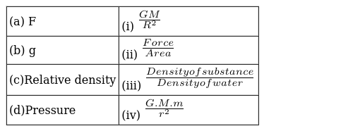  a) (a) - (iv), (b) - (i),(c) - (iii), (d) - (ii)  b) (a) - (iii), (b) - (ii),(c) - (iv), (d) - (i)  c) (a) - (ii), (b) - (iv),(c) - (i), (d) - (iii)  d) (a) - (i), (b) - (iii),(c) - (ii), (d) - (iv) | [1]
42 | Match the following with correct response.(1) Density (2) Relative density (3) Acceleration due to gravity (4) Gravitational contrast (A) $Kg/m^{3}$ (B) $m/s^{2}$ (C) No unit (D) $Nm^{2}/Kg^{2}$  a) 1 - B, 2 - D, 3 - A, 4 - C  b) 1 - C, 2 - B, 3 - D, 4 - A  c) 1 - D, 2 - A, 3 - C, 4 - B  d) 1 - A, 2 - C, 3 - B, 4 - D | [1]
43 | Match the following with the correct response: 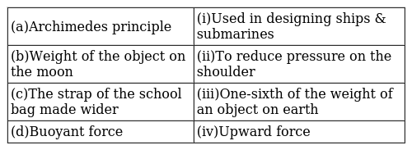  a) (a) - (i), (b) - (iii),(c) - (ii), (d) - (iv)  b) (a) - (iii), (b) - (ii),(c) - (iv), (d) - (i)  c) (a) - (ii), (b) - (iv),(c) - (i), (d) - (iii)  d) (a) - (iv), (b) - (i),(c) - (iii), (d) - (ii) | [1]
44 | Match the following with correct response. 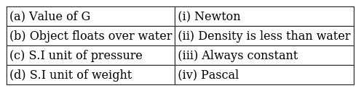  a) (a) - (iv), (b) - (i), (c) - (iii), (d) - (ii)  b) (a) - (ii), (b) - (iv), (c) - (i), (d) - (iii)  c) (a) - (iii), (b) - (ii), (c) - (iv), (d) - (i)  d) (a) - (i), (b) - (iii), (c) - (ii), (d) - (iv) | [1]
45 | Match the following with the correct response : 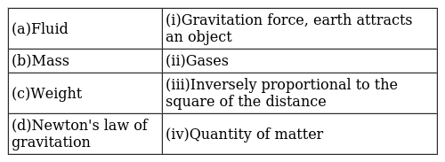  a) (a) - (iii), (b) - (ii),(c) - (iv), (d) - (i)  b) (a) - (i), (b) - (iii),(c) - (ii), (d) - (iv)  c) (a) - (ii), (b) - (iv),(c) - (i), (d) - (iii)  d) (a) - (iv), (b) - (i),(c) - (iii), (d) - (ii) | [1]
46 | Match the following with correct response. 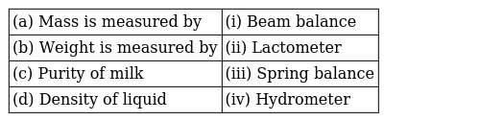  a) (a) - (i), (b) - (iii), (c) - (ii), (d) - (iv)  b) (a) - (iv), (b) - (i), (c) - (iii), (d) - (ii)  c) (a) - (iii), (b) - (ii), (c) - (iv), (d) - (i)  d) (a) - (ii), (b) - (iv), (c) - (i), (d) - (iii) | [1]
47 | Match the following with correct response. 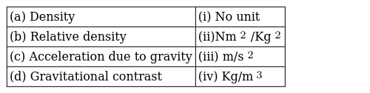  a) (a) - (i), (b) - (iii), (c) - (ii), (d) - (iv)  b) (a) - (iv), (b) - (i), (c) - (iii), (d) - (ii)  c) (a) - (ii), (b) - (iv), (c) - (i), (d) - (iii)  d) (a) - (iii), (b) - (ii), (c) - (iv), (d) - (ii) | [1]
48 | Match the following with correct response. 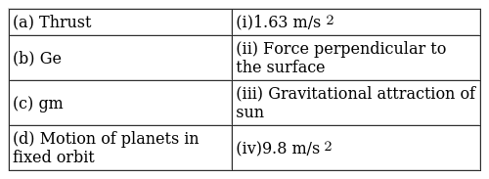  a) (a) - (iv), (b) - (i), (c) - (iii), (d) - (ii)  b) (a) - (ii), (b) - (iv), (c) - (i), (d) - (iii)  c) (a) - (iii), (b) - (ii), (c) - (iv), (d) - (i)  d) (a) - (i), (b) - (iii), (c) - (ii), (d) - (iv) | [1]
49 | Match the following with correct response. 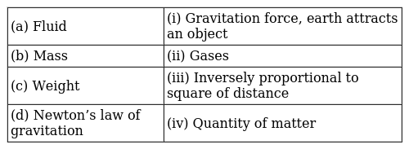  a) (a) - (iv), (b) - (i), (c) - (iii), (d) - (ii)  b) (a) - (i), (b) - (iii), (c) - (ii), (d) - (iv)  c) (a) - (ii), (b) - (iv), (c) - (i), (d) - (iii)  d) (a) - (iii), (b) - (ii), (c) - (iv), (d) - (i) | [1]
50 | Match the following with the correct response : 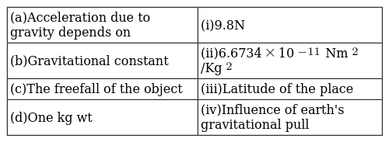  a) (a) - (i), (b) - (iii),(c) - (ii), (d) - (iv)  b) (a) - (ii), (b) - (iv),(c) - (i), (d) - (iii)  c) (a) - (iii), (b) - (ii),(c) - (iv), (d) - (i)  d) (a) - (iv), (b) - (i),(c) - (iii), (d) - (ii) | [1]
51 | Match the following with the correct response : 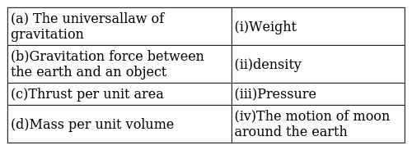  a) (a) - (iii), (b) - (ii),(c) - (iv), (d) - (i)  b) (a) - (ii), (b) - (iv),(c) - (i), (d) - (iii)  c) (a) - (iv), (b) - (i),(c) - (iii), (d) - (ii)  d) (a) - (i), (b) - (iii),(c) - (ii), (d) - (iv) | [1]
52 | Match the following with correct response.(1) Thrust (2) Ge (3) gm (4) Motion of planets in fixed orbit (A) Gravitational attraction of sun (B) $9.8​m/s^{2}$ (C) Force perpendicular to the surface (D) $1.63​m/s^{2}$  a) 1 - B, 2 - D, 3 - A, 4 - C  b) 1 - D, 2 - A, 3 - C, 4 - B  c) 1 - A, 2 - C, 3 - B, 4 - D  d) 1 - C, 2 - B, 3 - D, 4 - A | [1]
53 | Match the following with correct response. 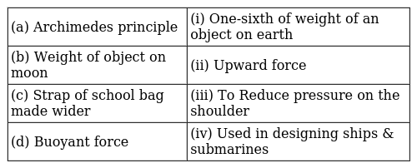  a) (a) - (ii), (b) - (iv), (c) - (i), (d) - (iii)  b) (a) - (iii), (b) - (ii), (c) - (iv), (d) - (i)  c) (a) - (i), (b) - (iii), (c) - (ii), (d) - (iv)  d) (a) - (iv), (b) - (i), (c) - (iii), (d) - (ii) | [1]
54 | Match the following with correct response.(1) Value of G (2) Object floats over water (3) S.I unit of pressure (4) S.I unit of weight (A) Pascal (B) Always constant (C) Newton (D) Density is less than water  a) 1 - A, 2 - C, 3 - B, 4 - D  b) 1 - C, 2 - B, 3 - D, 4 - A  c) 1 - B, 2 - D, 3 - A, 4 - C  d) 1 - D, 2 - A, 3 - C, 4 - B | [1]
55 | Match the following with correct response. 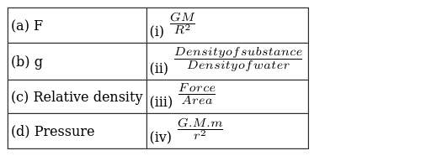  a) (a) - (i), (b) - (iii), (c) - (ii), (d) - (iv)  b) (a) - (iii), (b) - (ii), (c) - (iv), (d) - (i)  c) (a) - (ii), (b) - (iv), (c) - (i), (d) - (iii)  d) (a) - (iv), (b) - (i), (c) - (iii), (d) - (ii) | [1]
56 | Match the following with correct response. 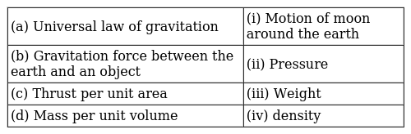  a) (a) - (iii), (b) - (ii), (c) - (iv), (d) - (i)  b) (a) - (ii), (b) - (iv), (c) - (i), (d) - (iii)  c) (a) - (i), (b) - (iii), (c) - (ii), (d) - (iv)  d) (a) - (iv), (b) - (i), (c) - (iii), (d) - (ii) | [1]
57 | Match the following with correct response. 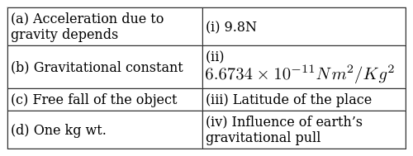  a) (a) - (i), (b) - (iii), (c) - (ii), (d) - (iv)  b) (a) - (ii), (b) - (iv), (c) - (i), (d) - (iii)  c) (a) - (iii), (b) - (ii), (c) - (iv), (d) - (i)  d) (a) - (iv), (b) - (i), (c) - (iii), (d) - (ii) | [1]
58 | Match the following with correct response.(1) Mass is measured by (2) Weight is measured by (3) Purity of milk (4) Density of liquid (A) Spring balance (B) Hydrometer (C) Lactometer (D) Beam balance  a) 1 - A, 2 - C, 3 - B, 4 - D  b) 1 - B, 2 - D, 3 - A, 4 - C  c) 1 - D, 2 - A, 3 - C, 4 - B  d) 1 - C, 2 - B, 3 - D, 4 - A | [1]
 | Section C
59 | If the distance between the object increase, mass remaining same then the gravitational forces between the object will ________.  a) Decrease  b) Remain the same  c) Increase  d) first decrease then increase | [1]
60 | If the area of an object is less,then the pressure acting on that object will be ________.  a) first, decrease then increase  b) More  c) Independent of area  d) Less | [1]
61 | The S. I unit of G is ________.  a) Nm/kg$​^{2}$  b) Nm$​^{2}$ /kg $​^{2}$  c) N$​^{2}$ m/kg  d) Nkg$​^{2}$ /m $​^{2}$ | [1]
62 | Freely falling objects weight ________ Newton.  a) zero  b) 9.8  c) 10  d) 980 | [1]
63 | A hydrometer sinks ________in water than in pure milk.  a) soft  b) less  c) hard  d) more | [1]
64 | Lactometer is used to measure ________of ________.  a) purity, milk  b) density, milk  c) purity, water  d) milk, water | [1]
65 | Inverse - square law means F$∝$ ________.  a) $\frac{1}{r}$  b) $\frac{1}{r^{4}}$  c) $\frac{1}{r^{2}}$  d) $\frac{1}{r^{3}}$ | [1]
66 | If the acceleration due to gravity at a place is more, the weight of that object will ________.  a) Decrease  b) Remains same  c) None of these.  d) Increase | [1]
67 | As the contact area between two objects increases the pressure ________.  a) decreases  b) remains constant  c) increases  d) zero | [1]
 | Section D
68 | Which of the statementis correct?  - Mass is constant and weight is variable  - Mass is variable and weight is constant.  - Both Mass and weight are variable.  - Both Mass and weight are constant.  a) (A)  b) (C)  c) (B)  d) (D) | [1]
69 | Which of the following statement is incorrect?  - When a body is thrown vertically upward the value of acceleration due to gravity is negative.  - When a body is thrown vertically upward its final velocity becomes zero.  - ​​​​​​​When a body is dropped freely from a height its initial velocity is zero.  - ​​​​​​​None of these  a) (C)  b) (B)  c) (D)  d) (A) | [1]
70 | Find the incorrect statement.  - Mass is a vector quantity.  - That planet will have large value of gwhich has large value of mass and small value of radius.  - Air resistance may make the acceleration different.  - When a body is thrown up, the acceleration due to gravity is directed upwards.  a) A  b) C  c) D  d) B | [1]
71 | Which of the following statement are incorrect -  - Value of acceleration due to gravity is same at all places  - Mass is constant at all places  - Weight is constant at all places  - Weight of an object can be zero.  a) A and D  b) All of these  c) A and C  d) B and C | [1]
72 | While determining the density of a metal block using a spring balance and a measuring cylinder, a student followed the following steps in this experiment.  - Noted the water level in the measuring cylinder without the metal block.  - Immersed the metal block centrally in water, without touching the sides and bottom of the cylinder.  - Noted the water level in the measuring cylinder with the metal block inside it.  - Removed the metal block from the water and immediately weighed it using a spring balance.  The incorrect step in the procedure is :  a) step C  b) step B  c) step A  d) step D | [1]
73 | Which of the following statement are incorrect -  - The value of acceleration due to gravity is the same at all places.  - Mass is constant at all places.  - Weight is constant at all places.  - The weight of an object can be zero.  a) A, Band Care correct  b) B and Care correct  c) All of these  d) A and Care correct | [1]
74 | Find the incorrect statement?  - The value of gincreases with depth.  - The value of gis more at poles and less at the equator.  - The value of g at the surface of the Earth is 9.8 m/s$​^{2}$ .  - The value of gdecreases with height.  a) D  b) A  c) C  d) B | [1]
 | Section E
75 | An apple falls from a tree because of gravitational attraction between the earth and apple. If F$​_{1}$ is the magnitude of force exerted by the earth on the apple and F $​_{2}$ is the magnitude of force exerted by apple on earth, then  a) F$​_{1}$ is very much greater than F $​_{2}$  b) F$​_{1}$ and F $​_{2}$ are equal  c) F$​_{2}$ is very much greater than F $​_{1}$  d) F$​_{1}$ is only a little greater than F $​_{2}$ | [1]

